**GIS in Water Resources-- CEE 6440-- Fall 2013**

**Term Project Final Report**

**Investigate the Capability of Arc Hydro Framework to Represent Water Management Data**

By: Adel Abdallah

Submitted to Dr. David Tarboton

Due: Nov. 6, 2013

Table of Contents

Introduction 3

Objectives 5

Methods 5

Results and Discussion 10

Conclusion 16

References 17

Introduction

There is an increased challenge to effectively manage scarce water resources. State-of-the-art management uses data-intensive models that require up-to-date, consistent, accessible, well organized, and documented spatial and temporal data and its associated metadata. Currently, data to describe water systems is scattered across numerous institutions, data providers, and models. Each source has its own way to organize and store data and use varied terms and phrases to describe data. Further, many operational aspects like decisions on how much water to release from a reservoir or the reason(s) to make releases are rarely documented. As a consequence, water managers and researchers spend a lot of time to compile data from scattered sources to analyze it and then build models of large systems. In fact, Horsburgh et al. (2008) summarized this challenge by pointed out that the way we organize data either enables or inhibits the analyses that we can do with it.

To overcome these challenges and enable the analyses that we can do with water management, the CI-Water research project at Utah State University is looking for a data model that facilitates the organization and analyses of water management data. The data model should enhance data-intensive hydrologic models that require water management data and thus enable high performance therefore computing. So there is a need for a data model that organizes spatial and temporal water management data to make sure data is represented in unambiguous way and users can interpret it correctly.

In this term project, I investigate to what extent Arc Hydro Framework can represent water management data and fulfil the needed data structure. But what is Arc Hydro Framework and what it does? Arc Hydro Framework, “Arc Hydro” or the “Framework” are interchangeably called hereafter is open source geodatabase design to represent basic spatial surface water and groundwater components within ArcGIS environment. The Framework was firstly implemented for surface water data and accordingly specific toolbox and toolbars were developed in ArcGIS to perform data analyses and surface water hydrologic modeling. This implementation was published in 2002 as the Arc Hydro data model and tools (Maidment, 2002). Later on the original Arc Hydro data model was redesigned to include a simplified framework for representing the basic features of both surface and ground water features (Strassberg et al., 2011). The improved Framework was also implemented within ArcGIS and accordingly toolbox and toolbars were developed and published in 2011 (Strassberg et al., 2011). Now, the term Arc Hydro refers to the overall data model for representing hydrology including surface water and groundwater. Yet there are two separate toolboxes and toolbars that can be used to perform data analysis and modeling for both surface water and groundwater.

The water components that Arc Hydro can represent can be like water body, water line, watershed, monitoring point, aquifer, and well. The Framework also supports temporal representation of water data through time series tables that can be linked to specific features. The Framework supports analysis of surface water and groundwater data together through relationships that connect features together like monitoring point, well, and aquifer (Figure 1) (Strassberg et al., 2011).

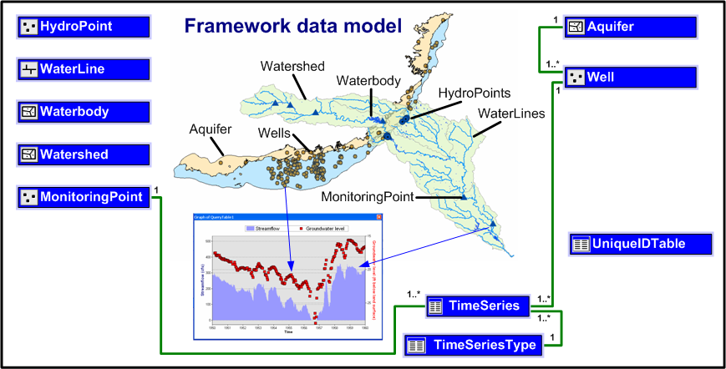

**Figure 1:** Arc Hydro Framework (Strassberg et al., 2011)

So to what extent Arc Hydro can represent water management data and support specific water management metadata types? To answer this question we need to define a set of criteria that water management data requires and check whether Arc Hydro can meet these criteria or not. If Arc Hydro does meet the criteria, then I will explain how we can implement these criteria within Arc Hydro. If not, I will explain why and how to proceed. I draw an example of water management data from an existing water management model for the Lower Bear River in Utah. I present the results and then conclude.

Objectives

The overarching objective in this term project is to investigate the capability of Arc Hydro Framework to represent water management data. This objective breaks down to three sub objectives:

1. Explore the Arc Hydro data model features and how could we represent water management data using this data model. Then study how Arc Hydro represents the network connectivity and whether it works for water management networks.
2. Import a water management data from the Water Evaluation and Planning System (WEAP) model using ArcGIS tools. The WEAP model can export the schematic of the water management network in KMZ file format which Arc GIS has a tool to import and convert to a shapefile. Bringing data from other models to ArcGIS can be very helpful as the third point explains.
3. Take advantage of the capabilities and tools of ArcGIS to represent, visualize and analyze geospatial data. Current water management models lack these capabilities and are built to focus on doing the modeling. For example, the WEAP model has powerful capabilities in analyzing water management scenarios but the user interface is not helpful to visualize important aspects that water managers look for like which reservoirs existed or are proposed? or show me the reservoirs that are built for flood protection?

Methods

This section is organized in three parts following the three objectives above. The section describes the methods I used to achieve each objective.

1. To achieve the first objective of exploring the features of Arc Hydro Framework and the connectivity of networks and whether we can use it in water management data, I define two criteria approach and examine each of them separately.

**Criteria**

1. Data representation criterion: Water management assets include surface water or groundwater features like well and water body and also include man-made infrastructure like cities and pipelines. Each of these assets requires numerous and different types of data and metadata attributes. These attributes can be physical or operational data or metadata (Table 1). Now, can Arc Hydro represent such water management data?

The current supported features and their data types in Arc Hydro Framework are generic features like Hydro Point which seem to accommodate any other kind of water management feature type. If not existed, the user can add it and add the appropriate attributes to it (Table 2).

**Table 1:** Example water management data

|  |  |  |
| --- | --- | --- |
| System Component | Physical Attributes | Operational Attributes |
| Rivers | Length, connectivity, inflow, reach gain/losses | Minimum required flows |
| Reservoirs | Capacity, release structures, elevation-storage-area curves | Purposes, zones, release rules, delivery targets |
| Canals | Length, connectivity, flow capacity | Diversion rules, demands served |
| Hydropower | Turbine type, capacity, efficiency | Energy demands |
| Demand site | Water use(s) | Priority, timing, water required |
| Ground-water | Recharge, well locations | Pump capacities, artificial recharge |

**Table 2:** Summary of types of water resources features supported by Arc Hydro Framework

|  |  |  |
| --- | --- | --- |
| # | Feature class | Types of water resources features supported by Arc Hydro Framework |
| 1 | HydroPoint | Bridge, DamWeir, Gate, Lock Chamber, Rapids, Reservoir, SinkRise, SpringSeep, Structure, Water Intake, Outflow, Waterfall |
| 2 | MonitoringPoint | Well, Water IntakeOutflow, Gate, DamWeir, Gaging Station, Gate, Lock Chamber, Reservoir, SinkRise, SpringSeep |
| 3 | WaterBody | Playa, Ice Mass, LakePond, Reservoir, SwampMarsh, Estuary |
| 4 | WaterLine | ArtificialPath, Bridge, CanalDitch, Coastline, Connector, DamWeir, Flume, Gate, Levee, Lock Chamber, Nonearthen Shore, Pipeline, Rapids, Reef, Shoreline, SinkRise, Sounding Datum Line, Special Use Zone Limit,  StreamRiver, Tunnel, Wall, Waterfall |
| 5 | Well | Irrigation, Monitoring, Public Supply, Domestic, Industrial, Commercial, Stock, Test Hole, Unused |

So there are two methods to add or modify features in Arc Hydro Framework. The first one is through using Arc Diamgrammer software (ESRI, 2008) to access and modify the XML published schema of Arc Hydro (ESRI, 2011). The second method is to modify the geodatabase within ArcGIS. The user can add new or additional domains to existing or new attributes. I present an example of adding new features and modifying the Arc Hydro Framework using the two methods in the Results and Discussion section.

1. Connectivity criterion: Water management involves moving water from supply sources to demand sites (junctions) though conveyance links (edges) that comprise a network with flowrate that can go either way. An edge has two junctions and can be connected to any number of edges. For example, a reservoir junction can supply water to theoretically unlimited demand sites but one conveyance edge only connects one reservoir junction with one demand site junction. So can Arc Hydro represent a water management network and meet this criterion?

Well, Arc Hydro network connectivity meets this criterion and in case an edge has only one junction that is connected to it from one side, Arc Hydro generates a virtual junction on the end that does not have a junction. But Arc Hydro network generation tool is set up to work only with one line feature and one point feature only (Figure 2). So I used the ArcGIS tool “Create a Geometric Network” in the Geometric Network tools set in the Data Management tool box. This tool can generate a network from multiple point and line features and as in Arc Hydro, in case an edge has only one junction, then it adds a virtual junction to the other end.

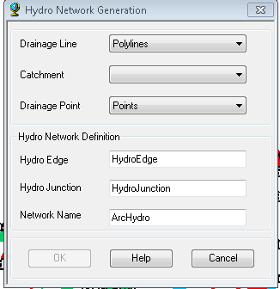

**Figure 2:** Snapshot shows the Hydro Network Generation dialog box

Once the network is generated, there are ArcGIS tools like the “Geometric Network Editing” to fine tune it and check the complete connectivity between junctions and edges. Although Arc Hydro was designed to represent hydrologic data that most likely has flow direction driven by gravity, interestingly, the Arc Hydro developers designed a tool to set up the direction manually if case water flows in the opposite directions! There is an Arc Hydro tool “Assign Flow Direction” that allows manual editing of flow direction for each edge through the attribute “FlowDir”. Arc Hydro has two tools “Set flow direction” tool and “Store flow direction” that create the fields in the line feature tables. There is another tool to set up the flow direction based on gravity called “Find Next Downstream Junction” but this tool is rarely needed in water management networks. Lastly, there is a very important Arc Hydro tool called “Generate From/To Node for Lines”. This tool creates the FROM_NODE and TO_NODE fields for each line feature in the "Line" feature class. Water management models usually use the “from” and “To” fields to describe the connectivity of the network.

There are four flow directions coded values that the user can choose from: (0) Uninitialized, (1) With Digitized, (2) Against Digitized, and (3) Indeterminate. There is also another attribute that indicates if the edge is open or blocked for flow called “Enabled” and has two coded values (0) Disabled, and (1) Enabled. The user can edit these two attributes for each single line feature in the network. This capability of manual editing flow directions is really a very important tool in water management where water rarely flows by gravity. Lastly, ArcGIS has a tool “Utility Network Analyst” to display the flow direction on the links as arrows. The user then can readjust flow direction manually to reflect the actual flow direction in the network.

1. This part first provides a context of the study area that is already represented in a WEAP model. Then I explain how we can import the WEAP model to ArcGIS using the existing tools in its environment. It’s important to mention that example of water management network serves as a proof of concept and represent the basic and fundamental water management aspects. Moreover, some of the data is hypothetical and used just to explain a concept. For example, I changed the purpose of some reservoirs from irrigation to flood control so I can show how we can represent different purposes of reservoirs. The WEAP model is set up for the Lower Bear River which starts at the Utah-Idaho state boarder and ends at the Great Salt Lake. Figure 3 shows the study area of the Bear River Basin (Rosenberg, 2013-a)

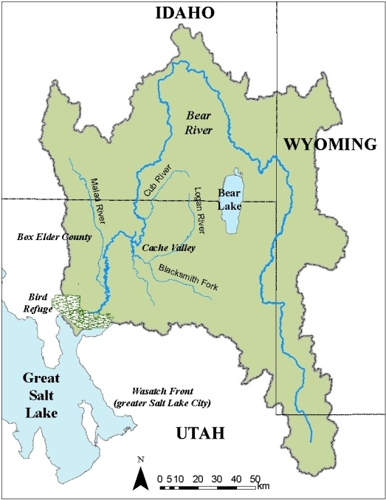 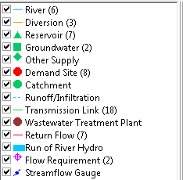

**Figure 3:** Bear River Watershed Left, WEAP model features for the Lower Bear River (Rosenberg, 2013-a)

I saved the schematic of WEAP as a KMZ file format then imported this file to ArcGIS using the tool “Import XML Work Space Document”. Then I used the “KML to layer” tool in the conversion tool box as shown in the left. This tool converts a KML or KMZ file into feature classes and a layer file. The layer file maintains the symbology found within the original KML or KMZ file. Then I imported the modified data model in step 1 as shown in Figure 4 and created a new geodatabase that is ready to handle the water management data. Then I used the ArcGIS tool “Load Data” to each feature class from the KMK data layer that I imported above. I used some queries to separate the generic point features and load them separately to the “Reservoir”, “Well”, and “HydroPoint” features.

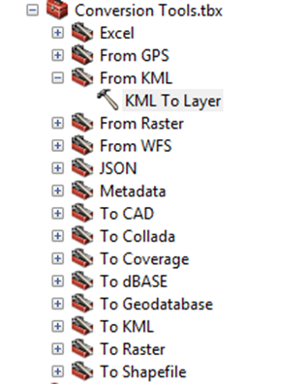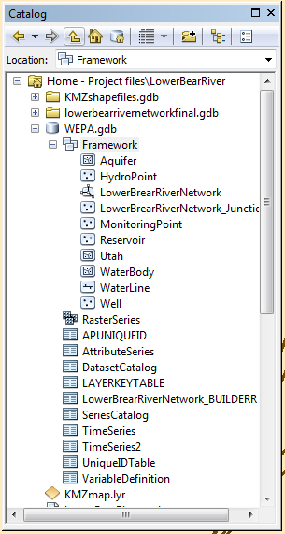

**Figure 4:** The **“**KML To Layer” tool (left) and the created geodatabse in ArcGIS (right)

1. Finally I take advantage of the capabilities and tools of ArcGIS to represent visualize and analyze geospatial data. ArcHydro has specific tools to visualize time series data. I used a tool called “a Time Series Grapher Set up” then “Generate Time series Graph” to produce the graph.

Results and Discussion

In this section I follow the three objectives and present results and discuss them for each objective.

1. According to the Data representation criterion I described in the methods section, I found Arc Hydro Framework to be generic and flexible enough to accommodate new futures and new attributes and domains. Moreover, the attribute can take one of many data types like text and integer. Therefore, we can add metadata attributes that describe water management operational activities. We can also define time series variables that can be connected to the Time Series Table. Thus Arc Hydro meets this criterion of being able to represent water management data. ArcGIS supports operational attributes that depend on state variables in the system and such functionality is already applied in may Utility models but it’s out of the scope of this project to investigate such functionality and how to represent it for water management data.

In the Figure 4 below, I show an example of adding a new feature called Reservoir then I added a table that defines the domain for the reservoir purpose attribute as either irrigation or flood control just as an example. For representing point features, the Framework has many domains but I added some more domains like “Diversion Outflow” Tributary Inflow. Figure 5 shows as example using the second method of editing the geodatabse within ArcHydro.

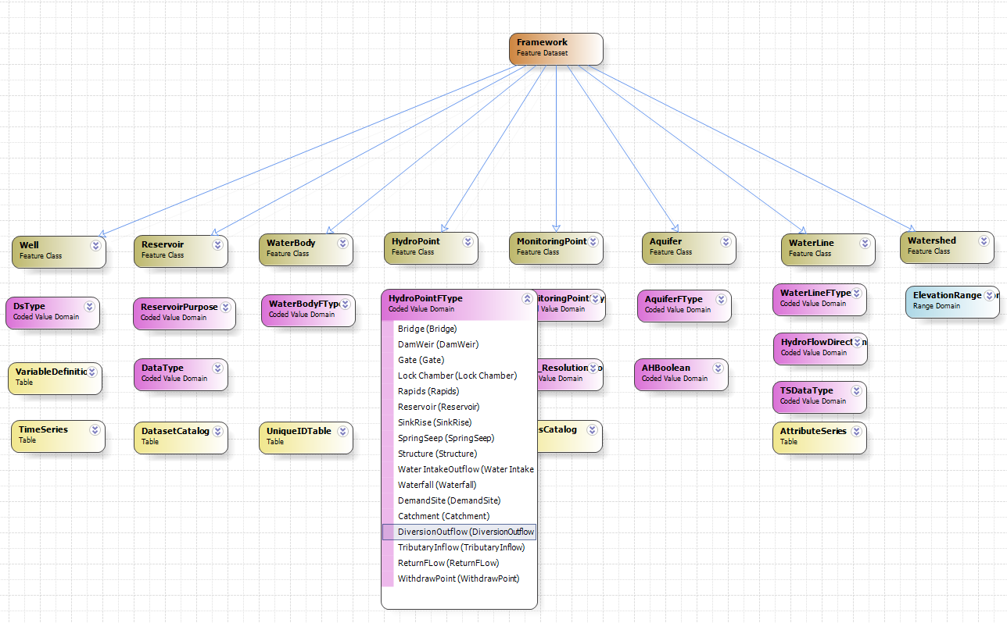

**Figure 5:** A snap shot of the modified geodatabase of Arc Hydro Framework using Arc Diamgrammer software (ESRI, 2008)

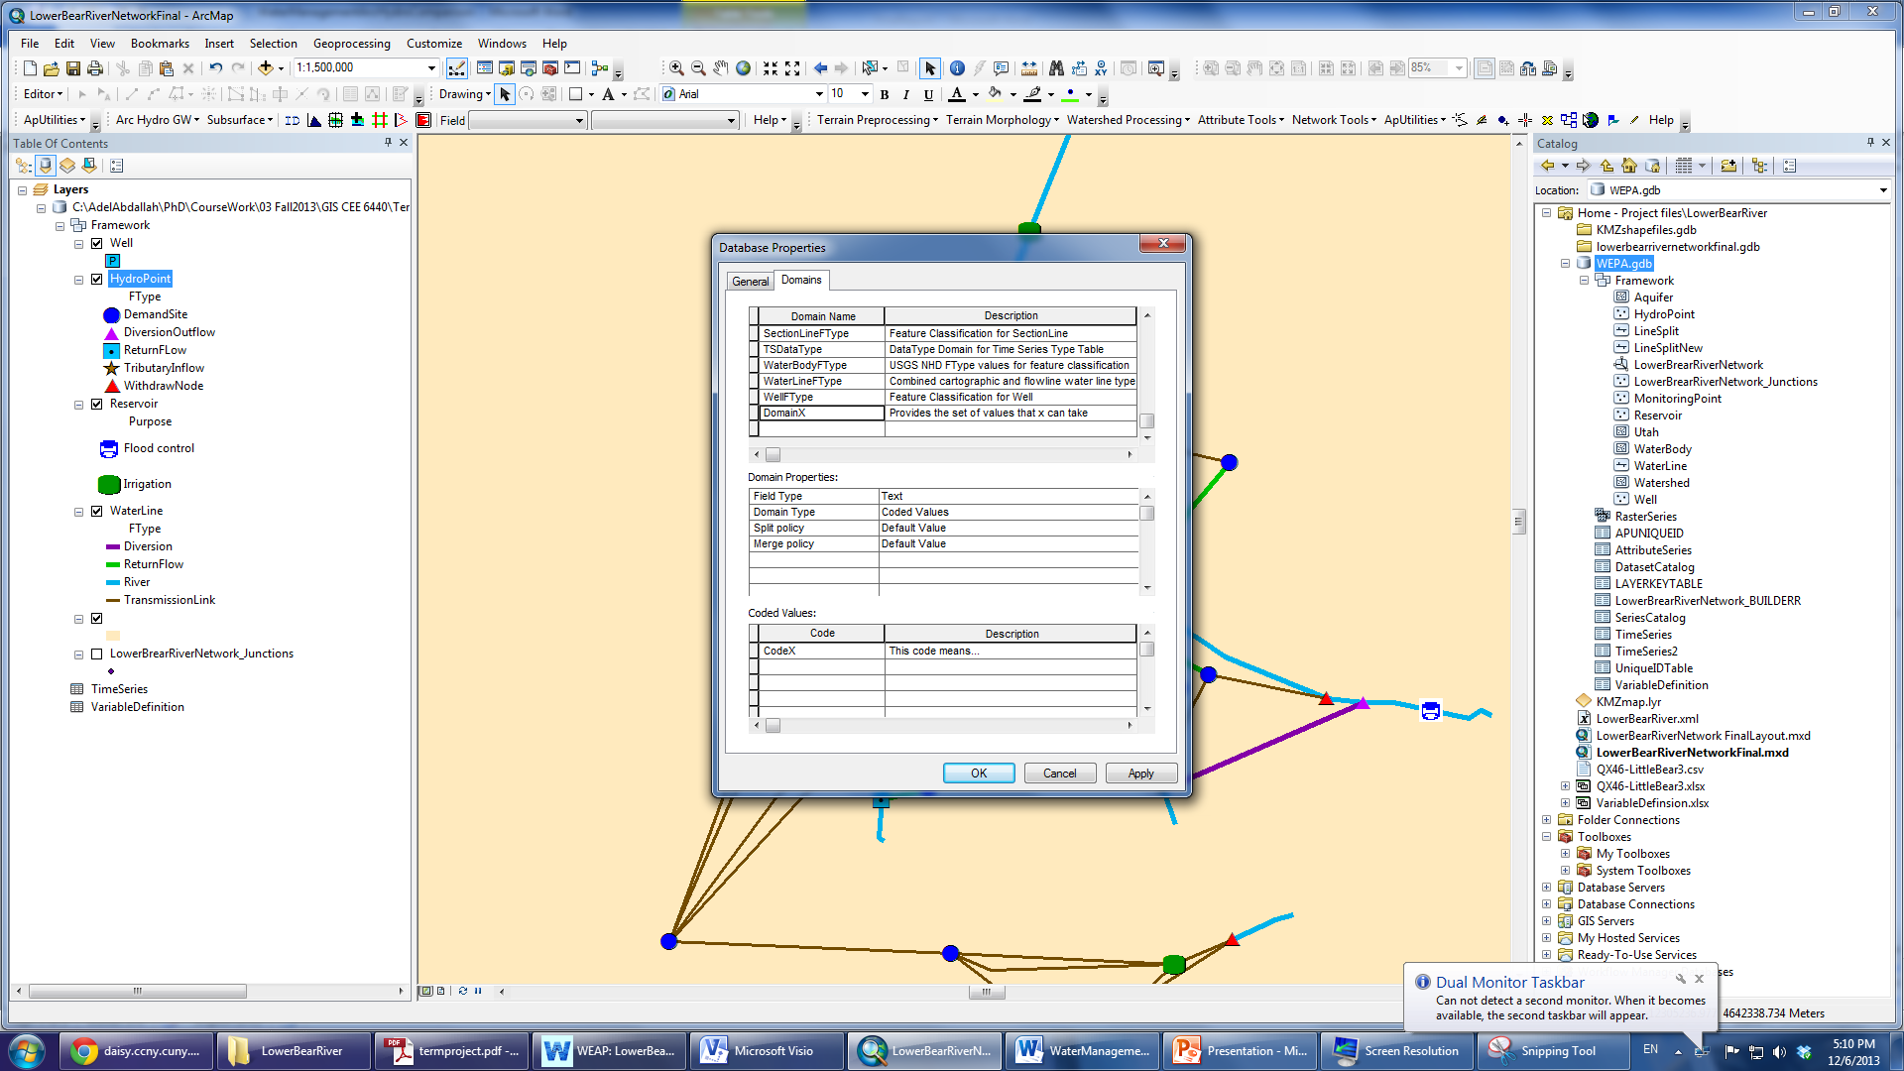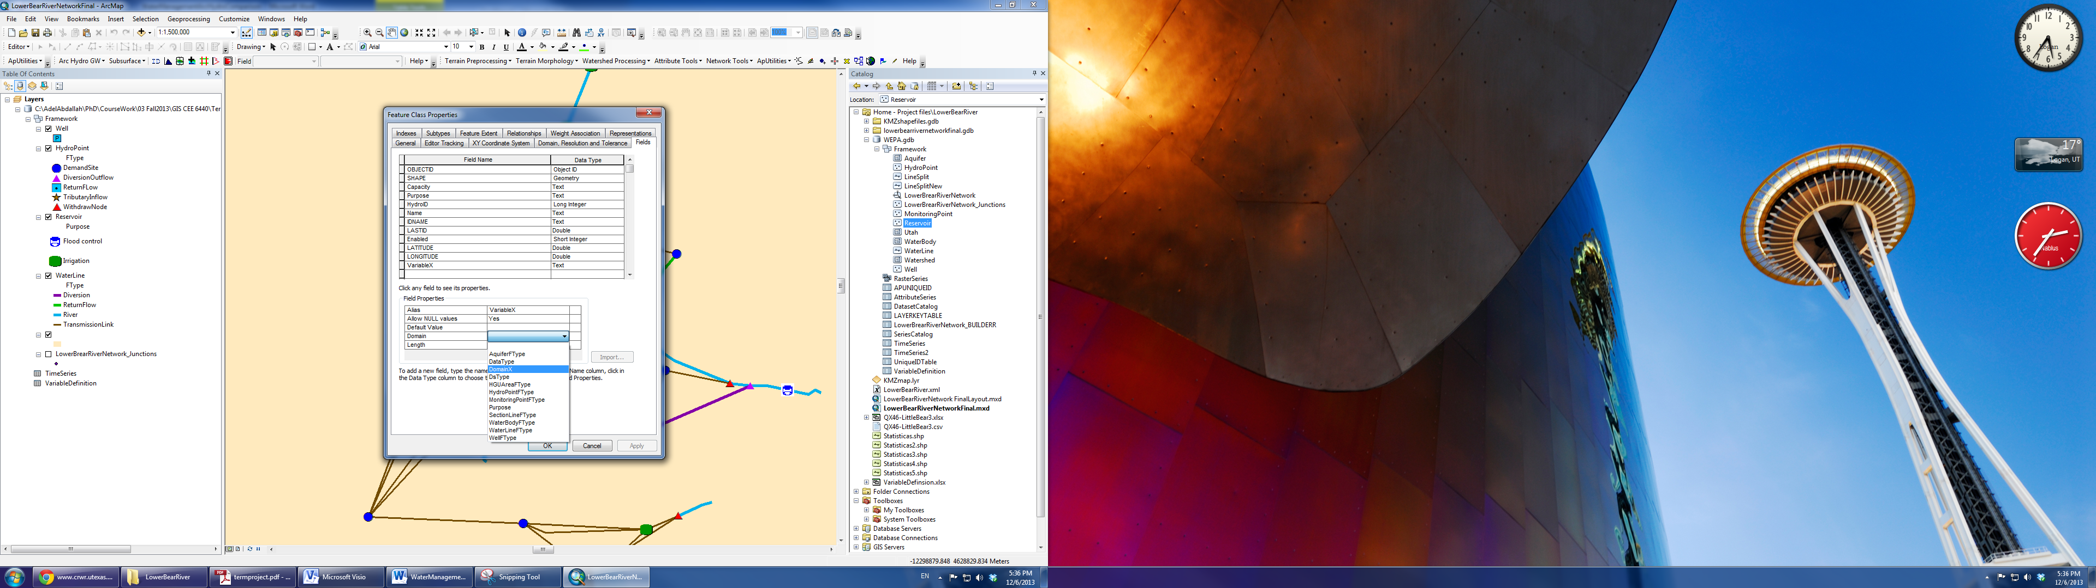

**Figure 5:** A snapshot shows how to add a new domain (left) and new variables within a new or existing feature like an edge or a junction (right) within Arc Hydro geodatabase

1. In this part I combine the second and third objective of importing the WEAP model and then suing some ArcGIS and Arc Hydro tools to visualize the data model. Figure 6 shows a map of the Lower Bear River water management Network represented in the modified Arc Hydro geodatabase. The Figure for example shows the flow direction and distinguishes between reservoirs by showing the purpose of reservoirs visually on the map. However, in WEAP it takes the user some time to figure out the direction of flowrate and purpose of reservoirs as this attribute cannot be visualized in WEAP.

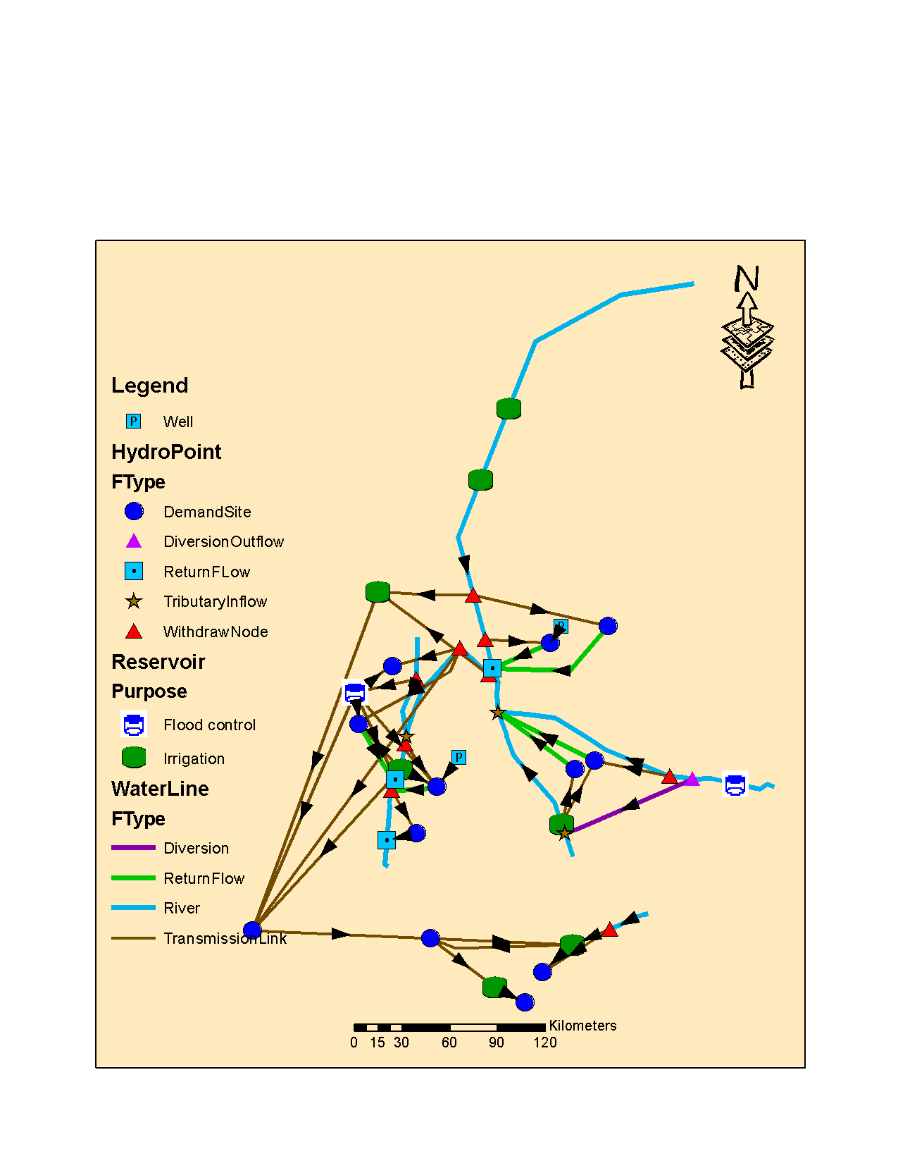

**Figure 6:** The Lower Bear River water management network

Using the data load tools I described in the methods section, Figure 7 shows one example of time series flowrate data for the Little Bear River. The Figure shows how the time series table is connected to the variable table and the Line tables through identity keys. This is really an important tool that allows us to map many relations between variables, time series, and attributes in the geodatabase features. Figure 8 shows the time series flow data for the Little Bear River

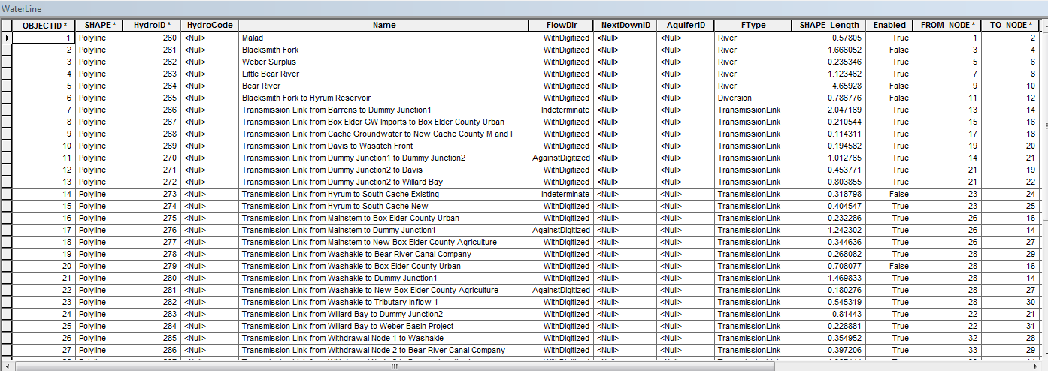

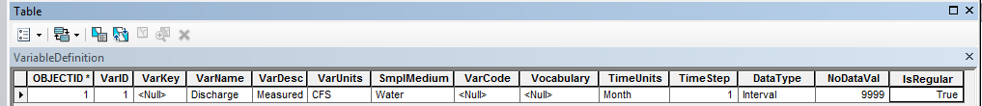

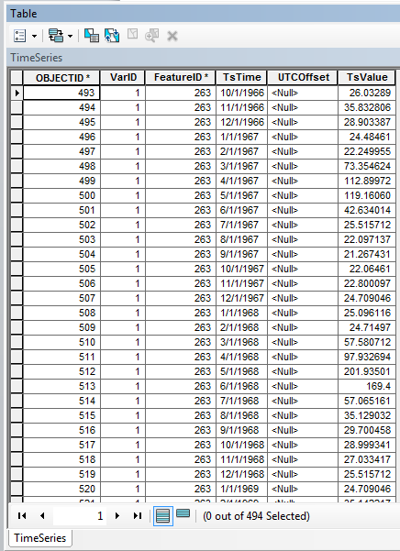

**Figure 7:** The attribute table of the Line object showing the fields like: assigned HydroIDs, line name, flow direction, type of the line, enabled, and “From” and “To” attributes.

C:\AdelAbdallah\PhD\CourseWork\03 Fall2013\GIS CEE 6440\TermProject\Project files\LowerBearRiver\LittleBearRiverHeadFlows.emf

Figure 8: flowrate time series of the Little Bear River Headflows

To summarize, Arc Hydro can represent water management assists with the desired network connectivity. Arc Hydro is flexible to modify its underlying geodatabase and can accommodate new features as the user wishes. In addition, Arc Hydro has a set of useful tools that can help setting the water management network like assigning universal HydroIDs, generate FromNode and ToNode that defines the connectivity between two junctions, setting flow direction and adjusting it manually to meet water management flow directions. “Enabled” attribute that defines whether the line is blocked for flow or not. On top of that, Arc GIS supports additional functionality if needed. For example, the Split tool allows the user to split lines in the network wherever there is a supply or demand point that emerges on the line.

Although Arc Hydro Framework is open source data model and can be accessed and modified but it is specifically designed to be implemented within the ArcGIS environment. The ArcGIS enterprise is proprietary software and its use is limited to the authorized users. Besides, GIS inherently is concerned with spatial information but largely static in time while water resources management is concerned with the condition of the continuous time changing water storage and flow changes from supply to demand (Maidment, 2013).

So we need an information model that imposes a standard on how water management data and metadata is organized and provides meanings to the data and how it is connected. For example, there could be many ways to document a piece of metadata within the flexible structure of Arc Hydro and therefore the generality of Arc Hydro design to accommodate different ways of data entry inhibit or ability to analyze and understand the data. An example on that could be adding an attribute called data source. Then we have to input this data source to each instance of a reservoir we have. Though all the data sources for all the reservoirs in our network could be coming from the same source. Thus it will be overwhelming to enter the same data source for each instance. Another approach could be implemented in the back end data model of Arc Hydro like adding a new table for data sources and then connect this table with a relationship with the reservoir feature. So having many approaches to document metadata could be misleading and confusing if we want to combine two separate data sets of water management into one dataset.

For the reasons mentioned above, there is a need for a universal information standard to represent water management data just like the Environmental Data Observation Data Model (ODM) (Horsburgh et al., 2008). This standard should be platform independent and structured to capture the minimum metadata that describes the data and accommodates the water resources data that continuously changes with time. So, currently I am developing the Water Management Data Model (WaM-DaM) as part of the CI-Water research project. Ultimately the insights I gained from Arc Hydro and Arc GIS helped me incredibly to advance the design of WaM-DaM and will help in the future to integrate Arc Hydro with WaM-DaM standards.

Conclusion

In this term project I investigated the capability of Arc Hydro Framework to represent water management data. I used two criteria approach to evaluate this capability: Arc Hydro to represent water management features and attributes and the connectivity of the network. As a result, I found out that Arc Hydro Framework is generic and flexible to accommodate water management data and networks. But we still need a platform independent information model as a standard to represent water management data with its associated metadata. In the end, there is an incredible opportunity to take advantage of what Arc Hydro can do to help represent and visualize GIS water management data. Yet an information water management model has to elaborate on the structure of metadata and how to represent it in Arc Hydro.

References

* ArcHydro Groundwater 3.3.0 (for ArcGIS 10.2) Build Date Sep 19, 2013 <http://www.aquaveo.com/downloads?tab=0#TabbedPanels> downloaded Nov. 1, 2013
* Arc Hydro Groundwater Wiki [http://archydrogw.com](http://archydrogw.com/) Accessed Oct 20, 2013
* CI-WATER: Cyberinfrastructure to Advance High Performance Water Resources Modeling. <http://ci-water.org/> accessed Dec. 2, 2013
* ESRI ArcGIS Diamgrammer 10.01 (2008 release). <http://resources.arcgis.com/gallery/file/arcobjects-net-api/details?entryID=F12ADF8F-1422-2418-34B2-C276C6BCCF98> Accessed Nov. 10, 2013
* Horsburgh, J. S., Tarboton, D. G., Maidment, D. R., and Zaslavsky, I. (2008). "A relational model for environmental and water resources data." Water Resour. Res., 44(5), W05406.
* Maidment, D. R. (2002). Arc hydro : GIS for water resources, ESRI Press, Redlands, Calif.
* Maidment D. R., GIS in Water Resources Class, Utah State University and University of Texas at Austin: Lecture 12 “Water Data in Space and Time” Fall 2013
* Rosenberg, D. E. (2013-a) Personal communication. Map shows the Bear River Watershed
* Rosenberg, D. E. (2013-b) personal communication. WEPA model of the Lower Bear River water management network,
* Strassberg, G. J. N. L. M. D. R. (2011). Arc Hydro Groundwater : GIS for hydrogeology, ESRI Press, Redlands, Calif.
* Zeiler, M. E. S. R. I. (1999). Modeling our World : the ESRI guide to geodatabase design, ESRI Press, Redlands, CA.